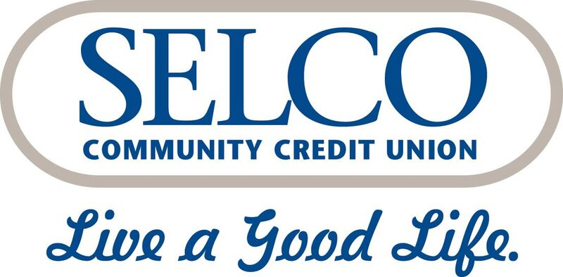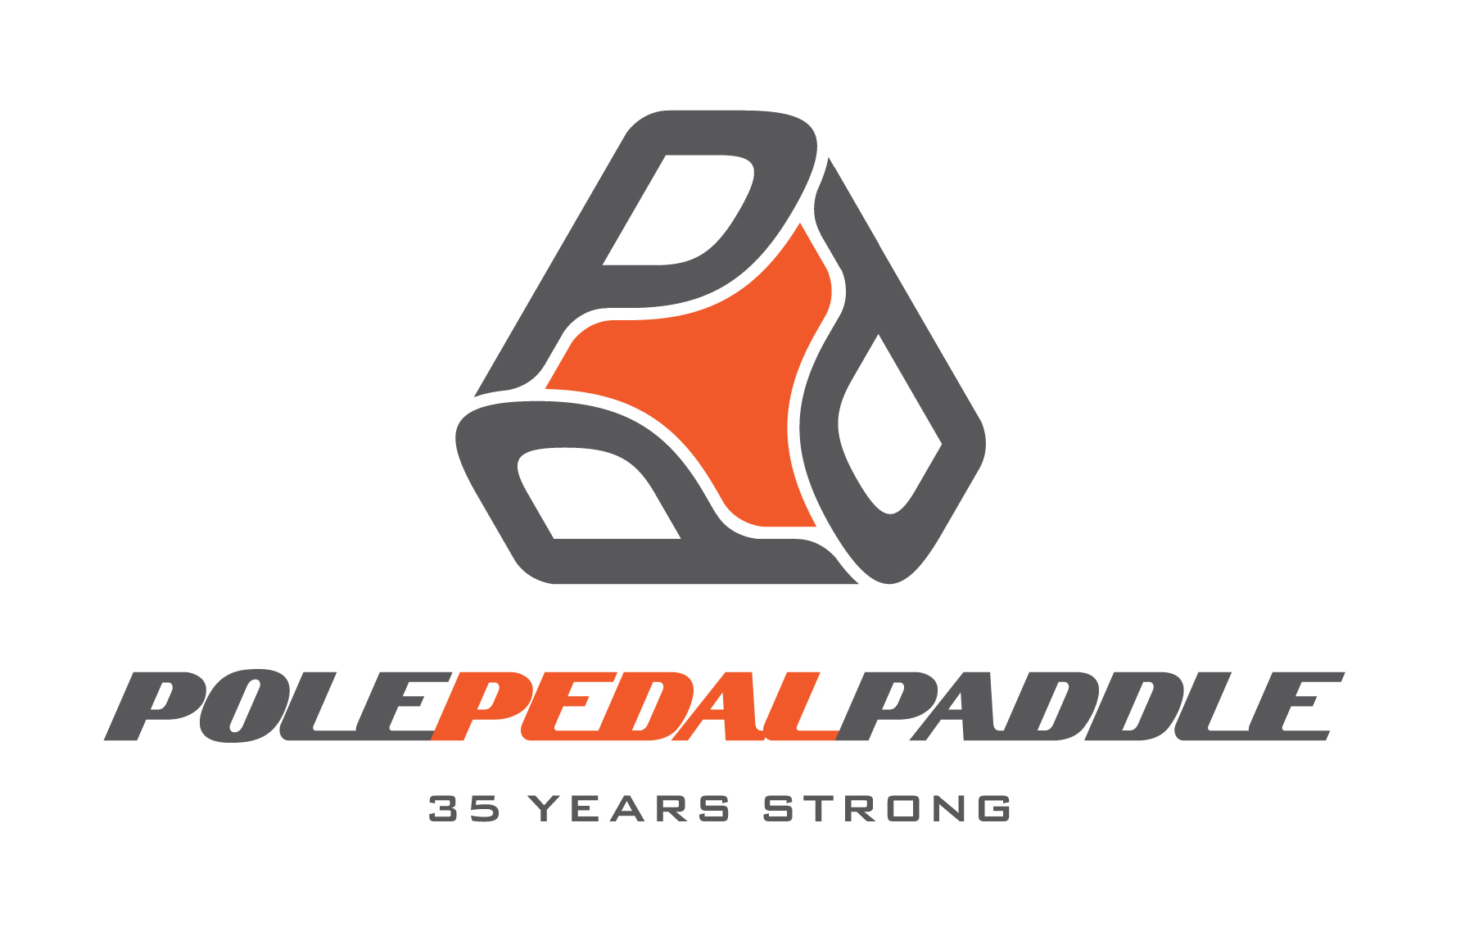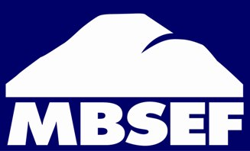

2022 SELCO Pole Pedal Paddle
Vendor Application & Contract

The SELCO Pole Pedal Paddle is the quintessential event of Bend, with over 5,000 racers/spectators at the West Event Grass in the Old Mill District race finish celebration. It’s the largest multi-sport event in Oregon. This is a great opportunity for you to market your business to over 5,000 outdoor recreation enthusiasts.

NEW THIS YEAR!

- The finish area will not be located in the Hayden Homes Amphitheater anymore. However, we are excited about the new location. It will be where the Art in the High Desert event takes place every summer. If you are unfamiliar with where that is, it’s the grassy area on the south side of the footbridge in the Old Mill District. So across the river from the Gap. The cool thing about this location is that everyone will be able to see a lot of race action. Across the river, we will be able to see the sprinters, and we will also be able to see the boaters on the river battling it out! The sprinters will cross the footbridge and finish right near the big Rock on the south side of the river. It’s going to be an epic finish.

- Being in the Hayden Homes Amphitheater was great, but I always felt a little removed from the race. It was hard to see any of the race. So we will be in the heart of the race! We are going to try and keep a lot of grass open for people to hang out in. Most of the vendors will be set up in the parking lot that is right along the grass. We will still have a stage, music, costume contest and awards presentation for the overall winners in each category.

SELCO PPP-MAY 14, 2022
- The race begins at Mt. Bachelor Ski Resort at 9:15 a.m. with the first finishers into the West Event Grass in the Old Mill District approximately at 11:00 a.m. Please be ready by 10:30 a.m. The day usually starts off a little slow, and then people come in droves by lunchtime. After 11:30 a.m., there will be a steady stream of racers crossing the finish line. This continues up until about 2:30 p.m. People are then just milling around socializing, looking at all the booths and hanging out. It’s very packed at this time! Awards are given out from 2:45 p.m. - 3:30 p.m. At 4:00 p.m. you may then break down and start loading up to go.

WHAT WE PROVIDE TO YOU
- A 10x10 space, access to power, a very organized crew to direct you in the morning, live announcements on race day in the Amphitheater that will drive traffic to your booth, exposure to over 10,000 people and an opportunity to participate in an event that is so rich with tradition. You will also receive two parking passes and a confirmation email 10 days before the event that will give you your allotted check in time and further instructions.

WHAT WE NEED FROM YOU-
- $300 and the below completed form by April 20, 2022
- Make checks payable to MBSEF. Mail to 2765 NW Lolo Dr., Bend, OR 97703
- You can also call 541-388-0002 and pay with credit card.

SELCO PPP May 14, 2022 10:30 A.M.- 4:00 P.M.

Company Name: _______________________

Contact Name:______________________________
Phone: _______________________

Email:__________________________________________
Mailing address: ________________________________

Will you need power? _____________ If so, how many outlets? ____________

Additional Information
ADA
In an effort to make events in Bend accessible for everyone, we ask that you pay attention to the following accessibility guidelines from the City of Bend:
- Sales or service counters should be no more than 36 inches from the finished floor or the ground, and the width must be at least 36 inches wide.
- All paths of travel must be free from cords and other obstructions. Cords may be covered with rugs, but rugs must be taped down on all sides.
- Price lists should be hung 36-39 inches from the ground

For more information on ADA guidelines, please contact the City of Bend Accessibility Department at 541-693-2141.

Molly Cogswell-Kelley
MBSEF
2765 NW Lolo Dr.
Bend, OR 97703
541-480-6975
molly@mbsef.org
www.pppbend.com

Booth Hours:
The SELCO Pole Pedal Paddle is May 14, 2022. The race begins at Mt. Bachelor at 9:15 a.m. with the first finishers into the West Event Grass in the Old Mill District area at approximately 11:00 a.m. You must be ready to sell by 10:30 a.m. Saturday morning until 4:00 pm. Set-up for your booth may start at 6:30 a.m. on May 14th, not the night before! I will assign you a time in and let you know your time two weeks before the event.

*Remember*
Major Sponsors of the SELCO Pole Pedal Paddle will get to select placement of their booth and work with our volunteers who handle layout prior to the event. All other vendors will be placed at the discretion of the event organizer.

Alcohol that hasn’t been purchased in the official beer area will not be permitted. If you bring in your own alcohol, we will have to ask you to leave. This jeopardizes the West Event Grass in the Old Mill Districts OLCC license.

Booth Requirements:
The Exhibitor, named on this contract is entirely responsible for the specified leased space (approximately 10' x 10'-you are renting the space only, tent, tables and chairs are not provided). The actual tent, etc. must fit within space specifications, unless special arrangements have been made in advance with the Race Director. Exhibitors are responsible to keep area clean and not to deface or damage the space in any way. Exhibitor must supply garbage cans and be responsible for emptying them when full into a designated dumpster. If electricity is required please specify the required AMPS the booth needs in the designated space below. The Exhibitor is responsible for supplying all necessary power cords.

Booth Regulations:
Each Exhibitor must comply with all local, state and federal laws.
Each Exhibitor must comply with all city ordinances, fire prevention instructions and regulations. All material within exhibit (i.e. tent) must be fire retardant.

Damages:
The SELCO Pole Pedal Paddle Race Organizing Committee, Mt. Bachelor Sports Education Foundation shall not be liable for any damages or expenses incurred by exhibitors in the event the race is delayed, interrupted or not held as scheduled. Furthermore, if there is any damage to the area of your booth space, exhibitors will be held responsible and billed for any repair costs.

Indemnity:
To the maximum extent permitted by the Oregon Constitution and the Oregon Tort Claims Act, Exhibitor shall indemnify and defend the SELCO Pole Pedal Paddle Organizing Committee and Mt. Bachelor Sports Education Foundation and their agents, employees and volunteer workers from any claim, loss or liability, including attorney's fees at trial or on appeal, or otherwise, arising out of, or relating to, the operation of Exhibitor's booth. This obligation to indemnify shall survive the termination of this contract and shall apply unless such claim or loss results from the sole negligence or willful misconduct of the SELCO Pole Pedal Paddle Organizing Committee or Mt. Bachelor Sports Education Foundation.

RELEASE:
The Exhibitor does hereby release, waive, discharge and relinquish any action, or causes of action, which may hereinafter arise, and agrees that under no circumstances will the Exhibitor prosecute or present any claim for personal injury, property damage or wrongful death against SELCO Pole Pedal Paddle Organizing Committee, or Mt. Bachelor Sports Education Foundation, or any agents, employees, servants or volunteer workers, for any such causes of action, whether the same shall arise by the negligence of any said persons or otherwise, except claims for willful or intentional misconduct. IT IS THE INTENTION OF THE EXHIBITOR BY THIS CONTRACT TO EXEMPT AND RELEASE SELCO POLE PEDAL PADDLE ORGANIZING COMMITTEE, MT. BACHELOR SPORTS EDUCATION FOUNDATION, SELCO OF OREGON, MT. BACHELOR, INC., THE CITY OF BEND, RACE SPONSORS, AFFILIATED ORGANIZATIONS, OTHER PARTICIPANTS, WILLIAM SMITH PROPERTIES, INC., RIVER BEND LIMITED PARTNERSHIP, RIVER BEND MASTER ASSOCIATION, RIVER SHOPS, LLC, MILL SHOPS, LLC, MILL A ASSOCIATES, MILLSITE MANAGEMENT COMPANY, RIVER BEND INVESTORS I, LLC, RIVER BEND INVESTORS II, LLC, SANDLOT PARTNERS, LLC AND OR ANY SUBSIDIARY, PROPRIETARY COMPANY OR CORPORATION, PARTNERSHIP, LIMITED PARTNERSHIP, LIMITED LIABLITY COMPANY, OR JOINT VENTURE THEROF, WHETHER EXISTING, PAST, PRESENT, OR FUTURE, AND ANY OF THEIR SUCCESSORTS OR ASSIGNESS, ARE NAMED AS ADDITIONAL INSURED OWNERS OR LESSORS OF PREMISES USED IN THE CONDUCT OF THE EVENT, OR THE RESPECTIVE DIRECTORS, OFFICERS, ADMINISTRATORS, SERVANTS, AGENTS, EMPLOYEES OR VOLUNTEERS OF ANY OF THE ABOVE FROM LIABILITY FOR PERSONAL INJURY, PROPERTY DAMAGE OR WRONGFUL DEATH CAUSED BY NEGLIGENCE.

I, the undersigned, agree that this Contract will be governed by Oregon law and the exclusive jurisdiction over claims will be in Oregon State courts, with venue in Deschutes County, Oregon. If any part of this contract is determined to be unenforceable, it is intended that all other terms be enforced.

───────────────────────────────── Date: ───────
Exhibitor’s Signature

